Afrobeat Popularity Capstone Report
Course: Machine Learning and AI (Essentials)
Genre: Afro beat
GROUP 3:

1. Executive Summary
The A&R department asked three questions:
- What makes an afrobeat track popular?
- Can we predict a hit?
- What moods exist inside the genre?
Using a dataset of 1,000 Spotify tracks labeled as "afrobeat" (reduced to 999 after cleaning), I applied regression, classification, and clustering. My analysis revealed two major findings.
First, audio features alone are practically useless for predicting popularity; they explain less than 2% of why a track succeeds.
Second, the "afrobeat" label in this dataset is heavily mixed with Latin American music, making the data noisy.
However, by grouping the tracks by their emotional feel, we successfully identified four distinct moods (e.g., "Late-Night Chill," "Festival Bangers") that the streaming service can immediately use to build curated, mood-based playlists.

2. The Data
Source and Size:
The data comes from the Kaggle Spotify Tracks Dataset, which contains 114,000 tracks across 100+ genres. We filtered this down to exactly 999 tracks labeled as “ Afrobeat”.
Data Cleaning:
We cleaned the data with three principles: remove structural anomalies, remove unobserved data, and preserve genuine audio features.
- Duplicates: We removed 1 exact duplicate track.
- Odd Values: The maximum duration was 13.81 minutes (3.5 times the median), which likely represents extended DJ mixes. We capped duration at the 99th percentile (7.5 minutes) to prevent these from skewing the regression. We also removed 15 tracks with a popularity of zero, as this indicates missing streaming data (dead uploads), not actual unpopularity. Finally, we removed interludes shorter than 1 minute.
- Feature Scaling: For distance-based models (Logistic Regression and K-Means), we used a Standard Scaler to ensure all audio features contributed equally to the model's calculations.

3. What the Data Shows (EDA)
We generated four charts; here are the two most revealing.
Chart 1: Top Artists by Track Count
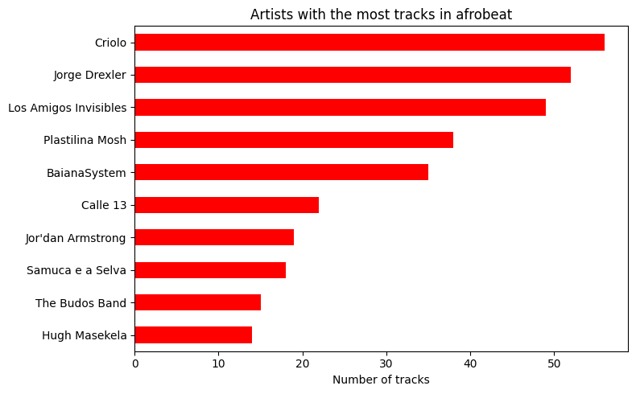
This bar chart revealed a major data quality issue. The artists with the most "afrobeat" tracks in this dataset are Criolo, Jorge Drexler, and Los Amigos Invisibles. These are overwhelmingly Latin American artists (Brazilian, Uruguayan, Mexican), not West African musicians. This means the streaming service should not trust the Kaggle genre label for regional accuracy, as the dataset conflates traditional Afrobeat with Afro-Latin fusion.
Chart 2: Popularity Distribution
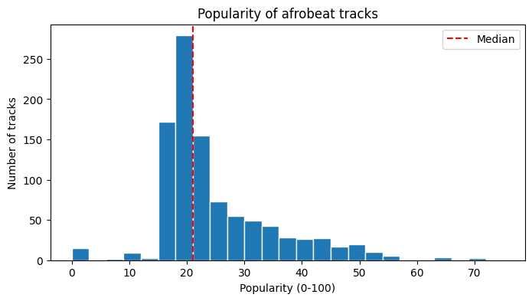
This histogram shows the distribution of popularity scores (0–100). The distribution is heavily right-skewed. The median is 21 out of 100, and the long tail only stretches to about 70. This means the streaming service should recognize that this dataset contains underground, niche music. A "hit" in this genre is not a track scoring 80; it is a track scoring 40 or above.

4. Predicting Popularity (Regression)
We attempted to predict a track's popularity using 10 audio features (danceability, energy, loudness, etc.). We tested two models on a 20% test set (200 tracks):
- Linear Regression: RMSE = 9.04, R² = 0.019
- Random Forest: RMSE = 9.52, R² = -0.088
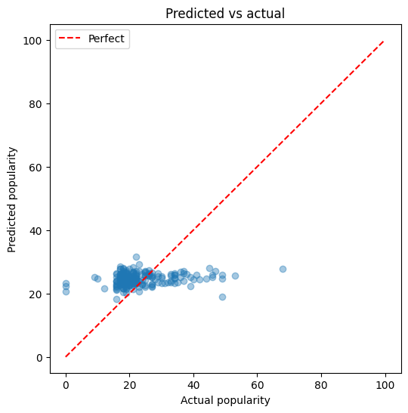
What this means in real terms:
RMSE stands for Root Mean Squared Error; it measures the average mistake the model makes in the target's units. Our best model (Linear Regression) was off by an average of 9.04 popularity points.
R² measures how much of the variation the model explains. An R² of 0.019 means the model only explains 1.9% of why a track becomes popular. The Random Forest performed worse, meaning it just memorized the training noise.
This means the streaming service should not invest in audio-based hit prediction. Because audio features explain less than 2% of popularity, the A&R team must look to external data (marketing spend, playlist placement, artist fanbase) to predict success.

5. Spotting Hits (Classification)
We defined a "hit" as any track with a popularity score greater than 35 (the top 14% of tracks). We trained a Logistic Regression classifier. Because only 14% of tracks are hits, we used balanced class weights to prevent the model from just guessing "Not Hit" every time.
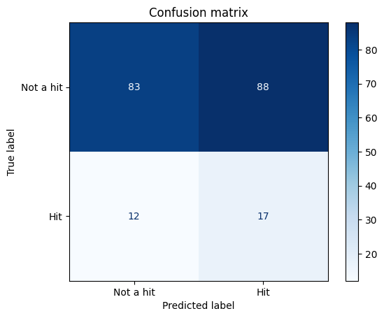
Our model's confusion matrix on the test set:
- True Negatives (83): Correctly identified as not a hit.
- True Positives (17): Correctly identified as a hit.
- False Positives (88): Wrongly flagged as a hit.
- False Negatives (12): Missed real hits.
Which errors cost more?
This means the streaming service should prioritize avoiding False Negatives (missing a hit) over False Positives. A false positive wastes a small amount of promotional budget a recoverable cost. However, a false negative means missing a track that goes viral, handing that artist's future revenue and audience to a competitor. A missed hit is a lost opportunity that cannot be recovered.

6. The Moods We Found (Clustering)
We used K-Means clustering on two features (valence/positivity and energy) to find hidden moods. The Elbow method suggested 4 clusters. We then averaged the popularity of each cluster (a feature the model never saw) to see which mood performs best.

Mood Name | Valence (0-1) | Energy (0-1) | Avg Popularity
0. Late-Night Chill | 0.51 | 0.40 | 25.64 (Highest)
1. Festival Bangers | 0.83 | 0.86 | 23.78 (Lowest)
2. Afrobeat Fire | 0.46 | 0.75 | 25.12
3. Feel-Good Groove | 0.82 | 0.65 | 23.97
This means the streaming service should stop treating afrobeat as a single block. The highest-performing moods are "Late-Night Chill" (mellow) and "Afrobeat Fire" (intense). The A&R team should create four distinct mood playlists and prioritize marketing for tracks in the top two performing moods.

7. Limitations
We must be honest about what this data cannot do. The 1.9% R² in our regression proves that audio features cannot capture marketing spend, playlist placement, an artist's existing fanbase, release timing, or social media virality. Furthermore, the popularity score is a snapshot of streams right now, not an all-time measure. A classic song from 2010 will score lower than a mediocre track released this week. Finally, the dataset contains significant genre mislabeling (the inclusion of Latin music), making the audio signature highly noisy.

8. Final Recommendations
Based on our findings, the streaming service should take the following actions, in priority order:
- Build Four Mood-Based Playlists: Immediately implement "Late-Night Chill," "Afrobeat Fire," "Festival Bangers," and "Feel-Good Groove." Prioritize the marketing budget on "Late-Night Chill" and "Afrobeat Fire," as these have the highest average popularity.
- Abandon Audio-Only Hit Prediction: Do not waste engineering resources trying to build a hit-predictor using just Spotify audio features. The signal is too weak (R² = 0.019).
- Implement a Human-in-the-Loop Flagging System: Use the Logistic Regression classifier not as an automatic decision-maker, but as a screening tool. When the model flags a track as a "hit," a human A&R representative should review it before promotional money is spent.

